Example1:

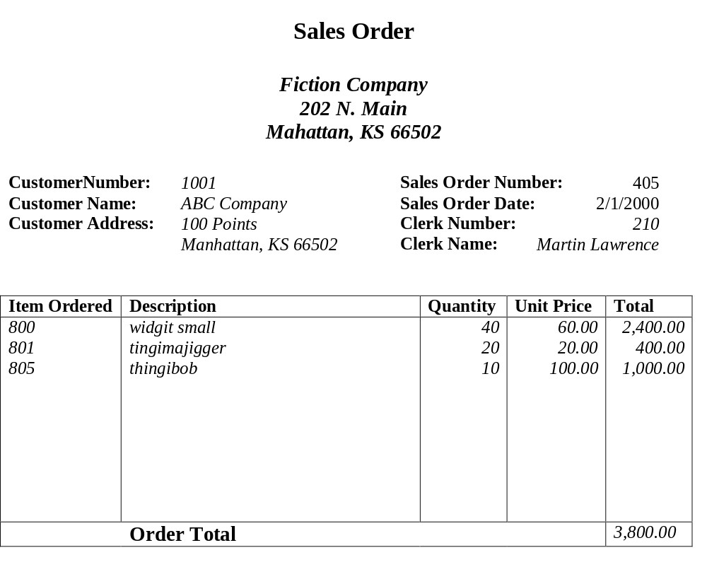

Primary Key: Sales Order Number,

Step 0:
receiptList:(SalesOrder, CNumber, CName,CAdd,SNumber, Sdate, clrkNumber, clrkName,ItemID,itemDes, itemQuantity, ItemPrice)

Step 1:
receiptList(SalesOrder, CNumber, CName, CAddress, SNumber, SDate, ClerkNumber, ClerkName)

Item (SalesOrder, ItemID, ItemDescr, ItemQuantity,ItemPrice)

Step 2 :

receiptList(SalesOrder, CNumber, CName, CAddress, SNumber, SDate, ClerkNumber, ClerkName)

Item_Receipt (SalesOrder, ItemID, ItemQuantity)

Item (ItemID, ItemDescr, ItemQuantity,ItemPrice)

Step 3 :

receiptList(SalesOrder, CNumber, SNumber, ClerkNumber, SDate)

Customer (CNumber, CName, CAddress)

Clerk (ClerkNumber, ClerkName)

Item_Receipt (SalesOrder, ItemID, ItemQuantity)

Item (ItemID, ItemDescr,ItemPrice)

Example2:
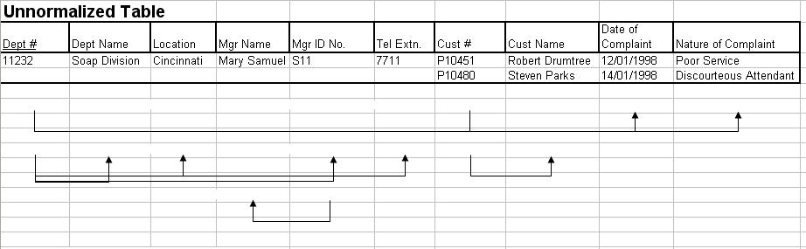

Step 1 :

Department (DID, DLocation, MGR_Name, MGR_ID, Tele)

Customer (DID, CID, CName, Comp_Date, Comp_Des)

Step 2 :

Department (DID, DLocation, MGR_Name, MGR_ID, Tele)

Customer_Department (DID, CID, Comp_Date, Comp_Des)

Customer (CID, CName)

Step 3 :

Department (DID, DLocation, MGR_ID, Tele)

Manager (MGR_ID , MGR_Name)

Customer_Department (DID, CID, Comp_Date, Comp_Des)

Customer (CID, CName)

